Learning Artificial Intelligence

Name of student

Name of professor

University

Course

Date

**Introduction**

Artificial intelligence is wide term used to refer to the latest technology involving data based decision making. What AI does is to integrate data from all sources, these sources can include data funnels such as data touch points, data reach streams like video coverage, comment feeds, customer portals and expert applications.

The integrated data is the fed into a single database application where it is stored. More often than not, big data is a term that is occasionally used to refer to data that is coming from all sources regardless of the amount, speed, size and form. This is what gives the so called heterogonous data. Heterogeneous data is data that comes in several forms. Traditional relational databases depended on data that is structurally well organized into tables and columns.

This meant that say if a column has say integer or number values, no other values can be contained in that column otherwise the database application will throw an error. With this kind of limitation, the application of unstructured database system came into play.

So generally what AI has done is to develop algorithms and models. Then take this models through the dataset and use them to train the datasets. Further the application of the dataset into the machine learning models require an 80% train and 20% test, also known as the Pareto rule. Once the trained data has been thoroughly tested, a predictive model can then be applied on the dataset, this model is then programmed through any language readily available and then inserted into the memory of the robot.

This is what gives the AI its name, artificially intelligent after learning from the data. The below is a simple illustration of how the artificial intelligent robots work.

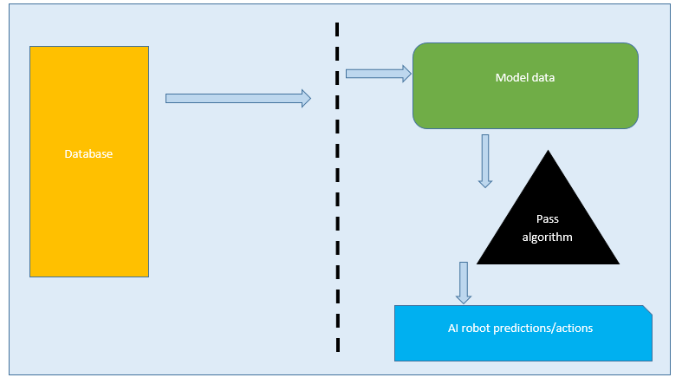

During the AI action plans, a lot of decisions are made on the memory of the application. Let’s take a simple case where, we have the self-driving tesla cars, there are conditions that are needed for say the implementation of the car whenever the car faces a huge traffic and it needs to stop. Below are some of the actions that could be taken into consideration by the car. These actions must be passed by the car based on the programmed memory:

**Case:**

The Tesla car is approaching a huge traffic corner and they need to reduce speed and halt with an approximate distance of 6m from the car ahead and 1.5M from the car behind. A sample Java code and conditionals would look like below:

public class teslaCar {

    public static void main(String[] args){

        float speed = 80;

        int distanceAhead = 3;

        float distanceAside = 1.5F;

        boolean carIsahead = false;

        float driveAhead = speed;

        if (carIsahead == carIsahead){

            System.out.println(driveAhead);

        }

    }

}

The Java code above has implemented the condition for the car to continue driving at a speed of 80km/hr. While the condition based on the car ahead is still is till not nearby.

**Artificial intelligence in tertiary institutions**

Artificial intelligence also taught at institutions of higher learning and below are some of the case studies on the courses, levels, requirements, objectives, challenges and benefits of studying these programs. Finally this is also an application of how some of these course are going to be helpful in developing some of the real world applications.

**Stanford University.**

The institution offers artificial intelligence based on their categories under this program at Masters Level:

* Machine learning; that deals with the interaction of data, modeling, predictions and forecasting on real world applications. Some of these models are applied in the development of artificial intelligent systems to the real world.
* Natural language processing: Just as Google NLP applications, these program targets the development and use of NLP modules to build artificially intelligent programs that will respond to voice and search.

For the entry into this course, an applicant must at least have a second class upper division in their undergraduate, studied within the information technology discipline.

Further, the course aims at training the graduates to become problem solvers by building smart agent application developers in there vases industries. The challenge with this course is that there are currently inadequate number of skilled smart agent developers that can fit the market and those who can fit the market force.

**Carnegie Mellon University**

This institution offers only artificial intelligent related courses that aim to build and help the common student aspiring to be the next lead developer become.

The course curriculum is intensive and includes the following:

* Cyber physical systems
* Coding boot camps
* Law of computer technology
* AI innovations

Some of the requirements for admission to this institution include:

* A GPA of 3.0 and above
* A GRE score
* A TOEFL pass
* A letter of purpose
* Transcripts

The major benefit of studying this program is that its course intensive and helps the interested engineer become fully equipped and ready to solve the real world applications and options available.

**Drexel Education center;**

This is institution offers accredited courses in artificial intelligence and machine learning. The program has a two pathway upon which a student can chose to either go the AI way or add onto themselves the machine learning element bit. For admission one has to:

* Have background in computing sciences
* Official transcripts
* A GRE score for international students
* At least a GPA score of 3.0 and above
* A letter of purpose addressed to the dean

The curriculum offers the following subjects;

* AI and capstone projects
* Deep learning
* Machine learning

The significance of studying in this course in this institution is the fact that the leaner is able to combine the two disciplines of machine learning and artificial intelligence at ago.

**Summary and conclusion**

Artificial intelligence is a hot subject dominating the current and future industries. Its application varies from field to field. As an upcoming hot topic, it should be widely embraced and applied across major discipline and institutions. The application of AI will help solve some of the current and future problems we have in medicine, industrial design, and mathematical computations and even in financial systems.

**References and sources**

<https://msaii.cs.cmu.edu/curriculum-0>

<https://cs.stanford.edu/academics/masters/choosing-specialization#ai>

<https://drexel.edu/cci/academics/graduate-programs/artificial-intelligence-machine-learning/ms-in-artificial-intelligence-machine-learning/>

Russell, S., & Norvig, P. (2002). Artificial intelligence: a modern approach.

Mueller, J. P., & Massaron, L. (2021). Machine learning for dummies. John Wiley & Sons.